Blue Group

CST-117

July 10, 2017

Mark Smithers

Milestone 1 Requirement Document

Introduction

“One of the most important responsibilities of being a computer programmer is the ability to determine the specific requirements of a business needs for the software they want you to build” (Grand Canyon university, CST-117).

Software requirement documents are written for identifying, and discussing in length what the client wants as discussed above. One of the purposes of the requirement document is to ensure that all the parties involved such as the developers, the client and the end users abide to the working and functionality of the application.

In line with that, the requirement documents, provide a clear guideline for the changes which can be made at a future date. The sole purpose of the software document is to give an overview of the software product and the set parameters to ensure its effective functionality.

The following is a list of the Blue group members who are going to work tirelessly in the creation of the software requirement document.

1. Adam Bartels
2. Fredrick Ondieki
3. Joe Donnelly
4. Jestin Toomer

The list of questions or paved the way on how we made the software requirement document.

1. **A statement naming the business client and what departments and/or individuals would be using the inventory software (Human Resources, Accounting, Customer, etc.).**

Upon discussion, we agreed that the name of our client will be **Blue Group Solutions.** and we will be building a Shipping and receiving system for **Stock Department**. The company will be receiving used car parts (cores) and shipping the product as remanufactured auto parts. We agreed on building the shipping and receiving system because most of us had similar experience on the industry and have also interacted with one system or the other.

1. **A list of questions the team will ask their client to find the functional and non-functional system requirements.**

The following list of questions developed by the team which will help in figuring out what the functional and non-functional system specifications need for the shipping and receiving software as well as what the client needs.

1. How do you track your inventory?
2. How many people will be using the system?
3. What shipping carrier do you use?
4. How many carriers do you use?
5. Will the shipping system need to connect to the carrier’s specific software?
6. Will the shipping system interact with any other inventory system?
7. Does the shipping system need to send any information to the recipient?
8. Do any other departments need to be informed of any information about items shipped?
9. How do you deal partial orders (orders that cannot be fully processed)?
10. How do you deal with breakage?
11. how do you deal with returns?
12. how do you track shipments that you receive?
13. how much interaction does shipping and receiving have with inventory?
14. **Client response to the questions**

The company will track the inventory using the built-in system. The stock inventory system will be update automatically. For instance, when goods are removed from the inventory, the database subtracts from the total number of goods on the stock. The inventory system will be used only by the stock department staff. The staff will have access to the system by user accounts.

The shipping carriers to use is particular to the customer. The various customers have their own carriers. For instance, the various carriers that will be used are;

* YRC Worldwide
* UPS Freight
* Fed-Ex Freight
* ABF Freight
* Estes Express lines
* Central Transport
* AAA Cooper
* Averit Express
* Dui Pyle
* Old dominion Freight line

The shipping carriers listed above will be fed into the system on each customer account details. Thus, many and shipping carriers will be used by the company. The shipping system will not need to connect to the customer carrier specific software other than to connect to the specific customer account where all the customer particulars are found prior to the account creation of the account by the customer.

The shipping and receiving system will interact with the stock inventory database as all the inventory transactions will take place. This is because goods will be added to the inventory by the receiving employees and will be coming out from the inventory to be shipped by the shipping employees.

The administrator will be needed to send information to the customer when goods are received as well as when the carrier load is shipped. Moreover, at times when the load cannot fit into the carrier, the manager will send information to the recipient that the remaining merchandise will come later with another different company carrier.

In addition, when goods are shipped or received, departments such as the accounts department will need the shipped information from the stock department inorder to prepare billing information or also to prepare refunds in case of goods or items returned by the customer.

On the other hand, the orders that cannot be processed; the information leading as to why the orders cannot be completed need to be communicated to the customer as well as to the accounts department.

When goods are returned to the company, it is either in two ways; goods that are damaged during shipping (breakages) or goods wrong units shipped to the customer. In the case of breakages, the count is taken and then set aside for repairs. On the other hand, the wrong units returned are inspected for quality and the reason as to why they were returned fixed. After the problems are fixed, these goods are then fed to the inventory database and the order processing process starts.

Receiving employees work together in feeding data concerning the received goods when the items are unloaded from the freights. Also, the damaged goods are separated from the other goods which are directly fed to the inventory.

Lastly, the interaction that exists between the shipping and receiving will need to actively interact with the inventory as one cannot exist on its own.

1. **The needs of the client based on the answers given.**

The client need to use the system to perform the activities according to the response on the questions listed above. For instance, the system should incorporate the carriers for the customers also listed above. In addition, the system should give access only to the authorized users inorder to protect private information.

Moreover, the system should automatically update the data base as the way goods are being received as well as when goods are being shipped. Also, the system shall need to connect to the accounts department so that customer bills can be prepared and sent to the customers. The data fed from the receiving department should be easily accessible and does not allow for any redundancy as this will negatively cause errors to the inventory.

The system to be developed will need to be user friendly and not to be complicated thus rendering difficulty to its users. The controls such as the tabs and windows should be accessible at ease. The least time that the system user should spend looking, feeding and searching information from the system should be less than 5 minutes. The system should abide to the company laws as well the state governing laws.

The system should be current and efficient to use and keeps up with the current level of technology. The system should be installed and used only on computers running windows operating system (Only company computers).

1. **Functional and Non-Functional specifications**

The functional system requirements include the statement of services that the system will be performing. The functional need also shows how users will interact with the system and how it should behave upon situations. Therefore, the stock department software functional system requirements include;

1. The system will enable the stock department employees who have valid access (Username and Password) to receive the raw materials and enter them into the system data base.
2. The client (Blue Group solution) can have many computers in the company and the new software will give functionality on all the computers.
3. The software shall allow the shipping clerk employees who have valid access to scan the ordered units by the customer before shipping. This in turn will remove the units from the stock database.
4. The system software will allow the system administrator for example the Manager to keep track and record of the whole company stock total units (Shipped and received).
5. Also, the administrator of the system will be able to view the customer data, the total units ordered, type of units as well as the carrier they will use.
6. In addition, the system will allow access to the administrator to create employee user accounts, update the customer data or update the employee data.
7. The system will allow units to be shipped only to the customer using the designated shipping carriers unless changed.

The non-functional part of the software requirement will address factors that may impose problems or constraints on the working and the implementation of the software. The constrains may emanate from the physical environment, security, legal policies/Organization policies, quality or even the standard system requirements. The non-functional system needs also includes;

1. The received and shipped products will need to have bar codes inorder to be scanned and easy data feeding into the system.
2. The company policy needs that the users of the system to have valid accounts inorder to access the system.
3. The system will be used by both shifts of the company
4. The system will handle the privacy details of the customers and can only be accessed by the system administrator during updates.
5. The system will conform to the legislative requirements of the regional state and have valid license and copyright rights.
6. The system will be user friendly as all the controls, tabs and button will be easily accessed.
7. New users to the system will need to be trained inorder to be familiar to how the system functions.
8. The software system will only work on personal windows operating system computers.
9. The novice user of the system shall be able to perform a transaction less than 2 minutes.
10. **Use cases**

Use cases are documents written to describe how the users of the developed software or application will interact with the whole software system itself. The use cases outlines, from a user’s point of view, a system’s behavior as it responds to a request. Each use case is represented as a sequence of simple steps, beginning with a user's goal, and ending when that goal is fulfilled.

**Benefits of Use Cases**

Use cases add value because they help explain how the system should behave and in the process, they also help brainstorm what could go wrong.  Use cases give a list of goals and this list can be used to show the cost and complexity of the system (Usability.gov, n.d.).

Therefore, per our system, I am suggesting that we include the following list as users to implement the use case example.

1. Manager –Administrator
2. Supervisors/Leaders
3. Employees.

The following are the use case examples for the Stock Management System.

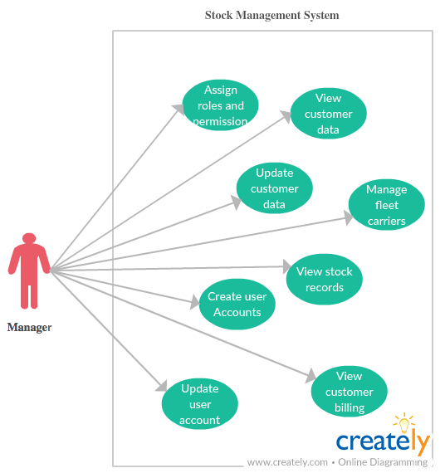

The above use case illustrates the user with the role of a manager who is also the administrator of the system.

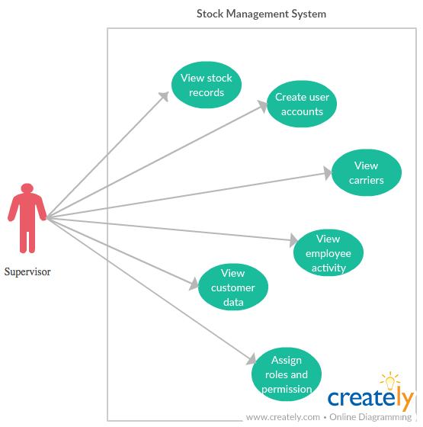

The above use case illustrates the user with the role of a supervisor who is also the team leader of the employees in the company.

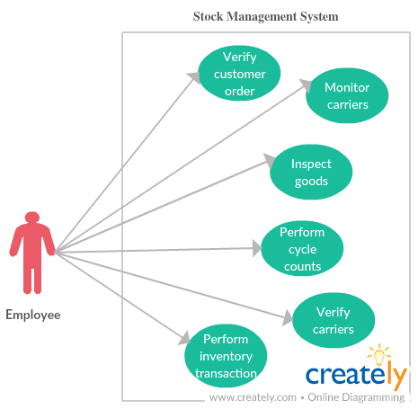

The above use case illustrates the user with the employee or an associate of the company.

1. **A storyboard of the end product.**

Inorder to make the storyboard (sometimes called, “use-case storyboard”), we need to describe what the use cases are so that we can in turn describe how users are going to interact with the GUI (Graphical User Interface).

The following story board describes the scenarios that that will be found on the system.

**Manager**

**View customer data.**

When the manager who is also the system administrator wants to view the customer data, the administrator will need to enter the identification number which is unique to each customer and presses the enter button. This will in turn display the customer details such as the orders requested, returns details associated with the customer.

**Update customer data**

The same procedure described above for viewing customer data is also followed when the administrator wants to update customer data. After the customer details have been displayed, the administrator will click the edit button to update the customer information and lastly in turn click the finish button to update the information.

**Create user accounts**

This role of the administrator which offers the opportunity to create employee user accounts. This will in turn allow the employees to have access to the system and perform the day to day activities of the company.

**Update user accounts**

After the user accounts have been created, this is where the administrator gets to update the user accounts such as password changes or even to remove non-existing employee access to the system.

**View stock records**

This button will allow the administrator to view the stock records. When the administrator clicks this button, the user can maneuver between the window and view the stock received as well as the goods being shipped.

**Manage fleet carriers**

The administrator can update the fleet carriers and view the carriers. In addition, this is where the administrator can see the scheduled shipping carriers as well the carriers that are delivering the raw materials. Also, this choice will allow the manager to assign a carrier for picking up the goods if not assigned.

**Assign roles and permission**

This window access allows the administrator to assign roles to individuals in the company. These roles are assigned as to the individuals which can have access to system like the administrator for instance the team supervisor.

**View customer billing**

To view the customer billing information, the administrator will enter the unique customer Id and press the enter button or click on the search button, then the customer billing information will be displayed.

**Supervisor**

**View stock records**

After the supervisor is allowed access to the system, the user can also perform functions in the same way the administrator will work. Here, the supervisor can view the stock received as well as the goods shipped. The supervisor can also keep track of the stock records.

**Assign roles and permission**

The supervisor can also sometimes delegate duties to another senior employee who is also the backup leader or back up supervisor. Therefore, the assistant leader will need access to the system inorder to perform the duties assigned, thus the supervisor will add the person as a user to the system.

Also, this window allows the supervisor to assign roles to the employees as who will have access as receiving employee or as a shipping employee.

**View customer data**

The system will allow access to the supervisor to view the customer data as which customer ordered what and in what quantity. Above all, it is where the supervisor will be able to print the orders from various customers and prepare the order for shipping.

**View carriers**

The supervisor will able be able to view carriers assigned to each customer or the freights that are delivering goods to the company. The supervisor will also have access to assign a shipping carrier to a customer if not assigned.

**View employee activity**

The supervisor will be able to view and monitor employee activities such as performance and the roles.

**Create user account**

The supervisor can able to create user accounts for the employees as well as update the user account details. This will in return allow the employees to have access to the system inorder to perform the daily activities.

**Employees**

**Verify customer orders**

The employee will have access to the system and verify the customer orders per the print outs from the supervisor and process the order according to the customer instructions.

**Perform inventory transaction**

The employee inventory transactions by feeding the data into the inventory system. This window will be mostly used by the receiving employees. Also, the returned goods are fed separately to the system before being returned to the stock database.

**Verify carriers**

The employee will have access to verify the fright carriers prior to shipping or offloading the goods. This confirms that the carriers picking up and delivering the merchandise are the scheduled frights carriers for the day.

**Monitor carriers**

The shipping employees will be able to watch the activities of the carriers for which customer is picking up the goods and which carrier is delivering the goods.

**Perform cycle counts**

The employee will perform cycle counts on the merchandise and record down and later feed the data in the system. The supervisor will be able to counter check these counts against the data stored on the database for the stock records.

**Inspect goods**

This where the receiving employee will inspect the quality and the quantity of the materials prior to offloading the trucks. Also, when the returned goods come in, the employee should be able to separate them from other goods.

**Revision History Table**

I believe that we will need to constantly need to update our document during the week and the next weeks to come. Therefore, the changes made on the document can be tracked here by the members. It is important that we write down where changes were made by describing the person who made the changes, where it was made, the date and description.

|  |  |  |  |
| --- | --- | --- | --- |
| Version | Date | Author | Description |
| V1.0 | July 10, 2017 | Joe Donnelly | Initial document creation. |
| V1.1 | July 11, 2017 | Fredrick Ondieki | Initial document review and editing. |
| V1.2 | July 13, 2017 | Fredrick Ondieki | Updated section 1.0, 3.0, 4.0 |
| V1.3 | July 15, 2017 | Fredrick Ondieki | Updated section 6.0 use cases |
| V1.4 | July 16, 2017 | Fredrick Ondieki | Updated section 3.0, 4.0, 5.0, 7.0, Reference |
|  |  |  |  |
|  |  |  |  |
|  |  |  |  |
|  |  |  |  |

Reference:

Usability.gov. Use cases (n.d.). Retrieved on July 11, 2017 from

<https://www.usability.gov/how-to-and-tools/methods/use-cases.html>

Use case tutorial (n.d.). Retrieved on July 13, 2017 from

<http://www.readysetpro.com/whitepapers/usecasetut.html>

Use case diagram (UML use case diagram) Retrieved on July 15, 2017 from

<http://whatis.techtarget.com/definition/use-case-diagram>

Use case. Retrieved on July 15, 2017 from

<http://searchsoftwarequality.techtarget.com/definition/use-case>

Use case tutorial. Retrieved on July 15, 2017 from

<http://www.readysetpro.com/whitepapers/usecasetut.html>